AIM: Controlling the Computer Console Using Voice Command on Windows Platform using C++.
Project Aim: Our Basic and complete AIM is to Operate the Console/Command Prompt of a Windows based Computer using the Voice of Human. It will be implemented on Evergreen Language C++. It will have lots of applications are as:
- Helpful for Physically Disabled.
- Fast access of Computer.
- If used in Embedded System, It will be a great way to Control a ROBOT with just a Voice command.
Method: The Model of My Project to be implemented for completion of the Objective is as:
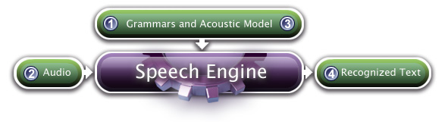
- Audio: It is the Human Voice input.
- Grammar: It is a CFG (Context Free Grammar) and is a set of Words to be detected in a perfect hierarchal format.
- SPEECH ENGINE: It is the main Recogniser programme to what my Application will be connected. SAPI is used for this purpose.
- Recognized Text: This is the required output from Recogniser. And this out-put will be sent to the Console to operate as a COMMAND.
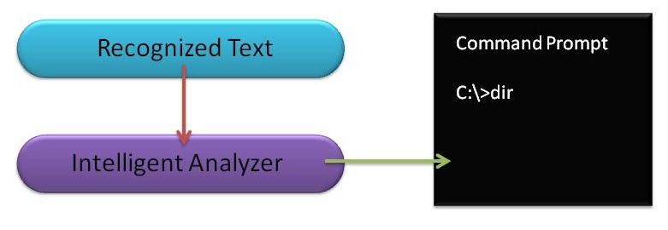
- Intelligent Analyzer: It is a subroutine to analyse the Recognised Text Output of Recogniser for a better estimation of Command.

Weekly Report:

1. Analogue & Digital Sound/Speech Signal:
Analogue Sound: Analogue Sound or Voice or Audio signal is Just a Mechanical Disturbance in Media. It is notable that it is usually not periodic. Even if it is periodic, there is always some difference in two Wave-Periods as there is always some Noise.
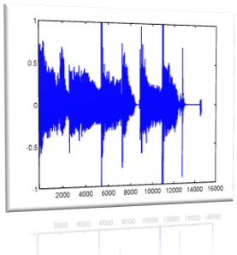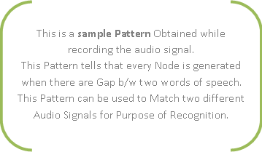
First of all, we have Digital Computer so there is no sense of Processing an Analogue Signal. So Study of Digital Signal Becomes Necessary. Here it is...

2. Digital Audio Signal: Digital Audio Signal is Just Digitized, Discrete, Sampled and Quantized form of Analogue.
The very Basic form of this Analogue-to-Digital Signal Transformation is: PCM- Pulse Code Modulation. One of these are LPCM- Linear PCM. You can visit Wikipedia for more detail. I am explaining it a little. viz
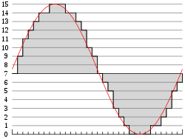
In the diagram, a sine wave (red curve) is sampled and quantized for pulse code modulation. The sine wave is sampled at regular intervals, shown as ticks on the x-axis. For each sample, one of the available values (ticks on the y-axis) is chosen by some algorithm (in this case, the floor function is used). This produces a fully discrete representation of the input signal (shaded area) that can be easily encoded as digital data for storage or manipulation. For the sine wave example at right, we can verify that the quantized values at the sampling moments are 7, 9, 11, 12, 13, 14, 14, 15, 15, 15, 14, etc. Encoding these values as binary numbers would result in the following set of nibbles: 0111, 1001, 1011, 1100, 1101, 1110, 1110, 1111, 1111, 1111, 1110, etc. These digital values could then be further processed or analyzed by a purpose-specific digital signal processor or general purpose CPU. Several Pulse Code Modulation streams could also be multiplexed into a larger aggregate data stream, generally for transmission of multiple streams over a single physical link. One technique is called time-division multiplexing, or TDM, and is widely used, notably in the modern public telephone system. Another technique is called Frequency-division multiplexing, where the signal is assigned a frequency in a spectrum, and transmitted along with other signals inside that spectrum. Currently, TDM is much more widely used than FDM because of its natural compatibility with digital communication, and generally lower bandwidth requirements.
There are many ways to implement a real device that performs this task. In real systems, such a device is commonly implemented on a single integrated circuit that lacks only the clock necessary for sampling, and is generally referred to as an ADC (Analogue-to-Digital converter). These devices will produce on their output a binary representation of the input whenever they are triggered by a clock signal, which would then be read by a processor of some sort.
Note: Quantization Rate X Resolution Height = Quality of Digital Signal = Size of storage required in KB

Reported By:
PERVEZ ALAM : WWW.PASSIT.YOLASITE.COM
07-CSS-48, 7th Sem,
B.Tech. in Comp Engg.
JMI, New Delhi.
Contact: Mr.PervezAlam@gmail.com
9268-159-707

